Criteria A
Description of the Scenario
The client for this project is my school canteen. The canteen serves meals to students and teachers throughout the school day. The canteen provides pre-ordered meals or normally ordered meals throughout the school day. In the discussion I had with the canteen manager, the current system is basic, efficient and entirely manual. The orders are made at in person, causing long waiting lines and confusion, confusion with providing orders for the right person and problems with payments (they take pictures of each mobile transaction).
The manager showed me her concerns on how the current system affects the food and service quality, especially during lunch time. Teachers in our school often have duty times at different locations, meeting where it’s difficult to leave their classroom and also the waiting time disrupts their workflow. On the other hand, the canteen doesn’t have an effective way to register new orders, or send new orders to chefs effectively. Although they do this manually (verbally or writing), this has been resulting in human error and losing orders. These inefficiencies have created customer unsatisfaction and affects the canteen’s workflow.
The Solution
To counteract this problem, I proposed developing a user-friendly digital ordering system that allow teachers to pre-order their meals to be delivered to their location on in the school. The program will have a customized UI for different roles to ensure a tailored experience. The application will allow users to select items, add menu items, check prices and send the orders directly to the canteen’s system.
For the canteen employees, the system should help them manage menu items, update new items, update availability and view coming orders in real-time. Also, the system I’m creating should be able to store previous order history and generate useful data such as their most-ordered items and should provide the canteen staff with day-by-day updates (if the canteen want).
The manager enthusiastically agreed to this solution, and we conducted a 20-minute discussion to clarify the scope and requirements for the system, eventually settling on a web app for the users and canteen.
Rationale for the proposed product
To address these challenges, I intend to use Java and MySQL for the canteen UI application. For the user UI, I plan to use Java. IntelliJ’s advanced debugging tools and project structures features allow me to efficiently write and manage code. Java provides me with strong OOP support which will massively help create a modular, maintainable, and streamlined program. IntelliJ provides a faster, cleaner, and more modern development experience which is particularly useful for creating large programs such as my digital ordering system with many classes and database interactions. Also, for my database I intend to use Supabase to store user information, menu items, and order history. Using this, I can efficiently connect the system to the Supabase database and ensure smooth data flow from the backend and frontend.
Success Criteria
- Users can securely log in and be redirected to role-specific panels (teacher or staff)
- The system should allow school emails only and require email verification before log in.
- Teachers can cancel their order 2 minutes after their order (not allowed after).
- Program should generate reports for revenue and most-ordered foods.
- User passwords are securely stored using hashing.
- Users can edit their profile (eg. First name, last name, telephone)
- Users can change their password if needed.
- Teachers should be able to select items, add them to a cart and place orders.
- Teachers can place comments on how they want their before they confirm order (it is optional).
- Teachers should be able to specify their delivery location when placing an orders.
- The database must store user and order information without duplicates.
- Teachers should be able to view their past order history within the system by entering a date or range (eg. 12 Apr - 15 Apr).
- Teachers should be able to add, delete and edit locations they want items delivered to.
- Received order history must be stored and accessible to staff.
- Canteen staff should be able to easily add, edit and remove items.
- Canteen Staff should be able to view their incoming orders.
- Orders must be placed before the daily cutoff time (4:00 PM) and has to be on a week day to be accepted.

[482 Words]

Criteria B
Wireframe Design:
Figure 1: Teachers UI
Welcome Page: The user can either sign-up or log-in. Canteen staff can log-in with their pre-made accounts.
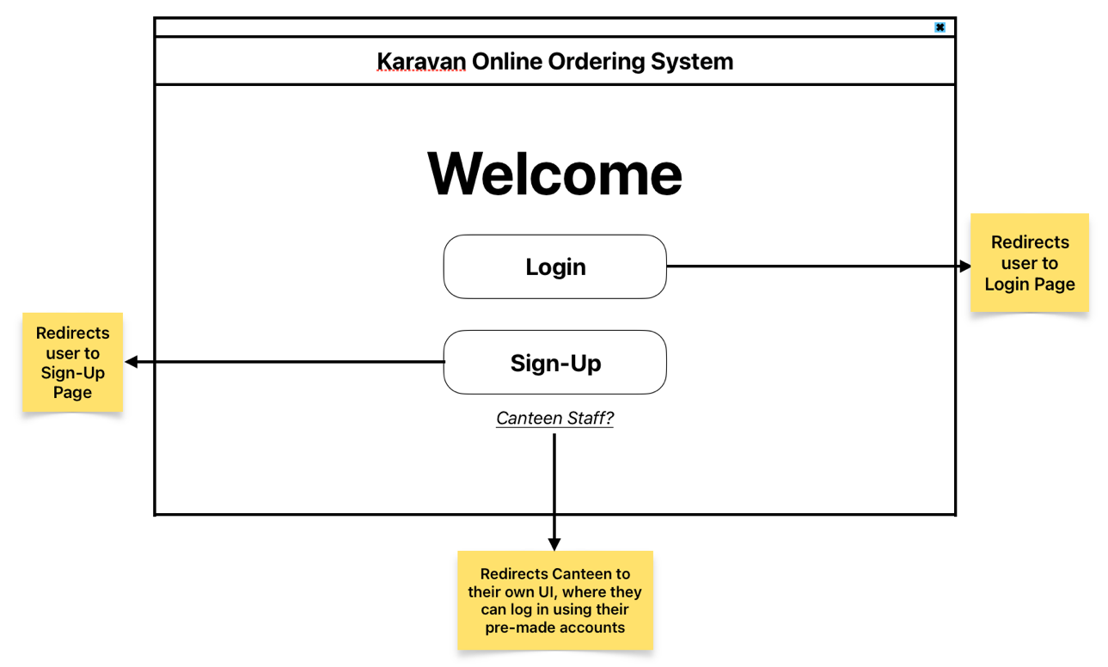

Figure 2: (Teachers UI)
Log-in Page: The user can log-in using their respective email and password. Or, they can either press forgot password to reset their password or press ‘Don’t Have an Account?’ to create one.
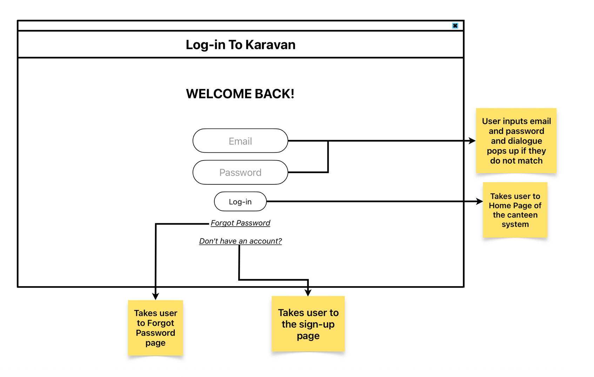

Figure 3: (Teacher’s UI)
Sign-up page: User enters details and will get a verification code afterwards. Once verification code has been inputted the user will be redirected back to the log in page.
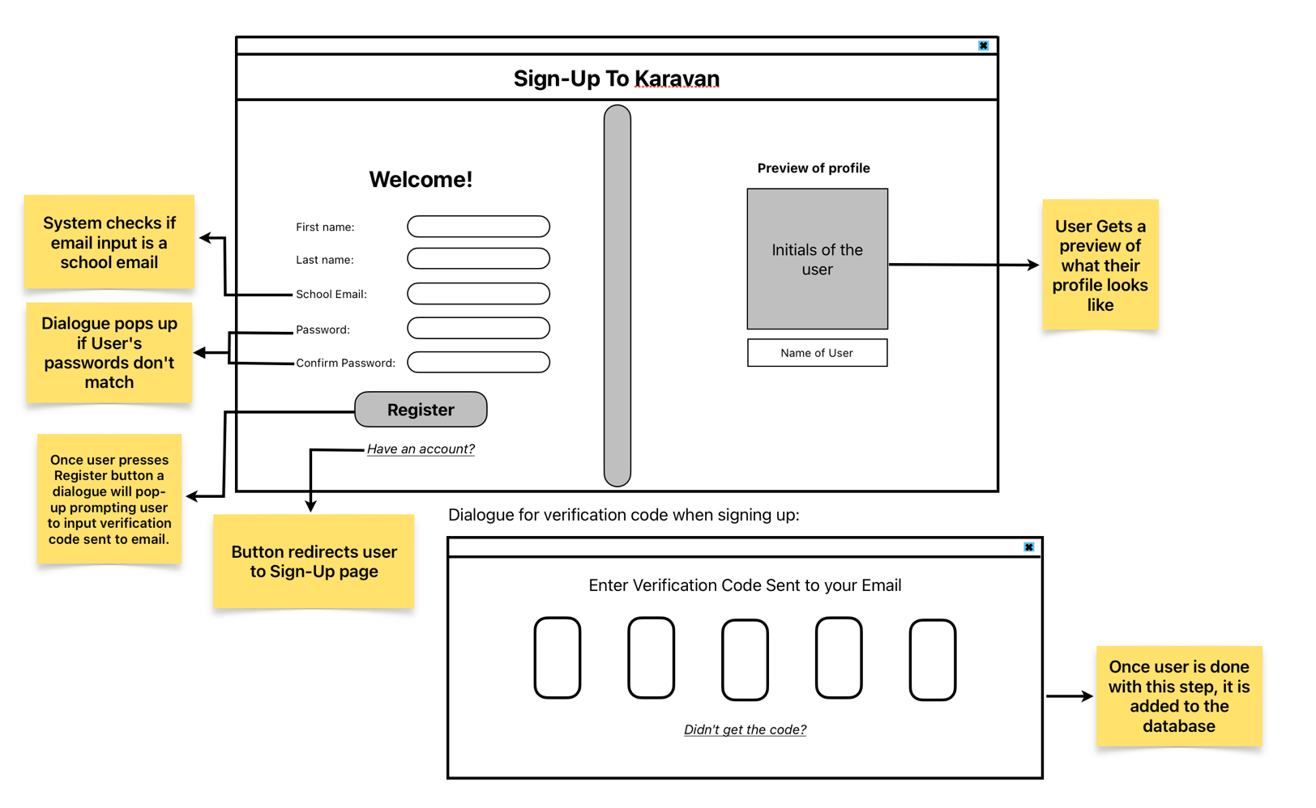

Figure 4: (Teacher’s UI)
Forgot Password: User enters email and a code will be sent. Once the user enters the correct code, password can be changed successfully.
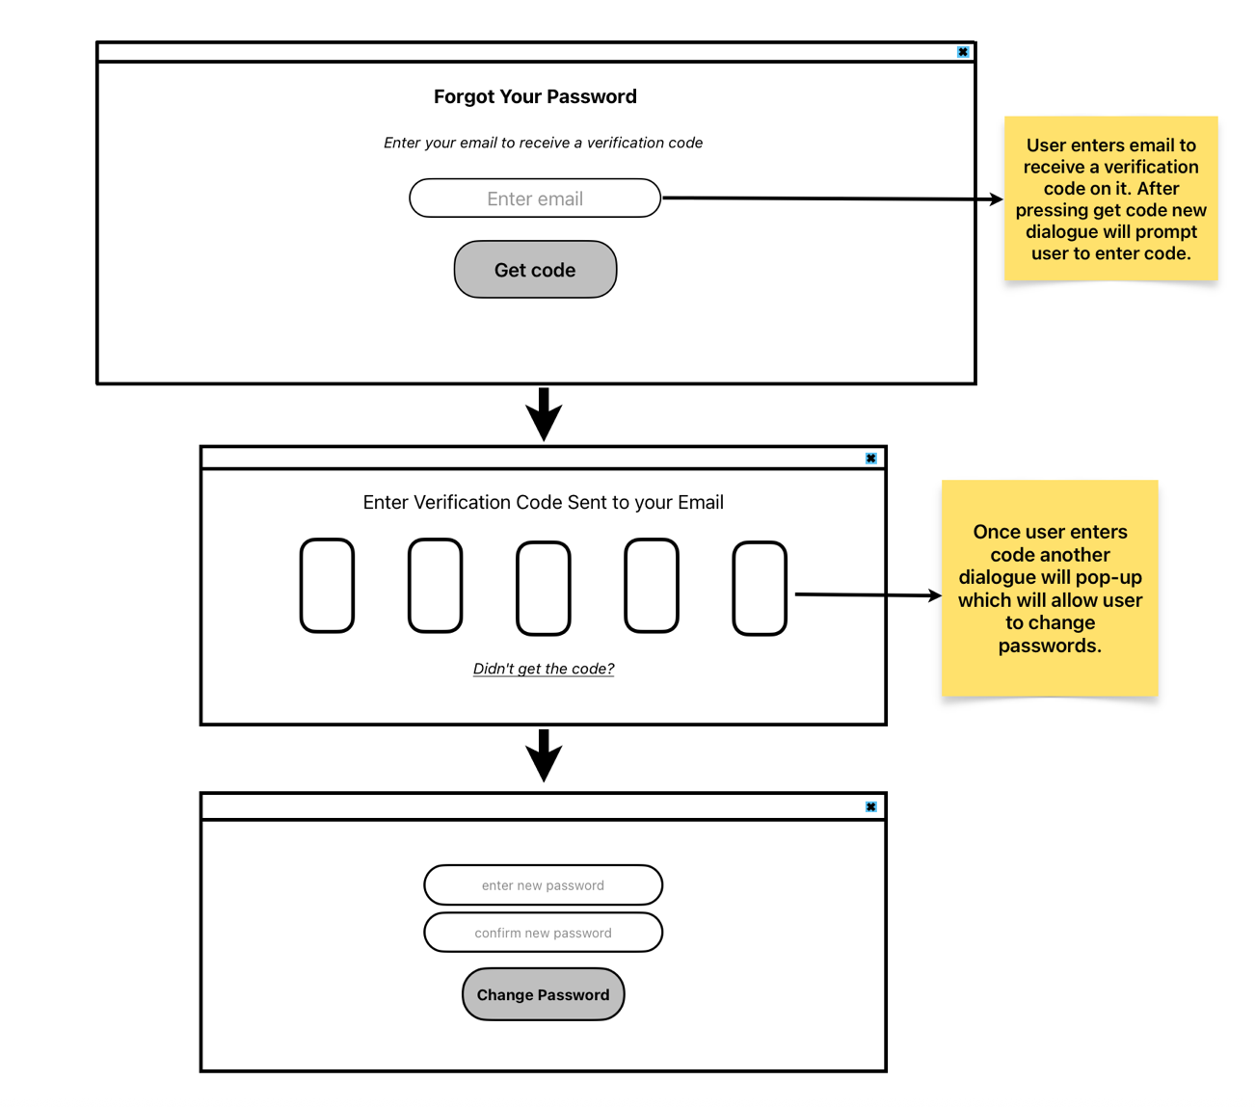

Figure 5: (Canteen UI)
Log-in panel for canteen staff: Canteen staff can log-in using their pre-made account.
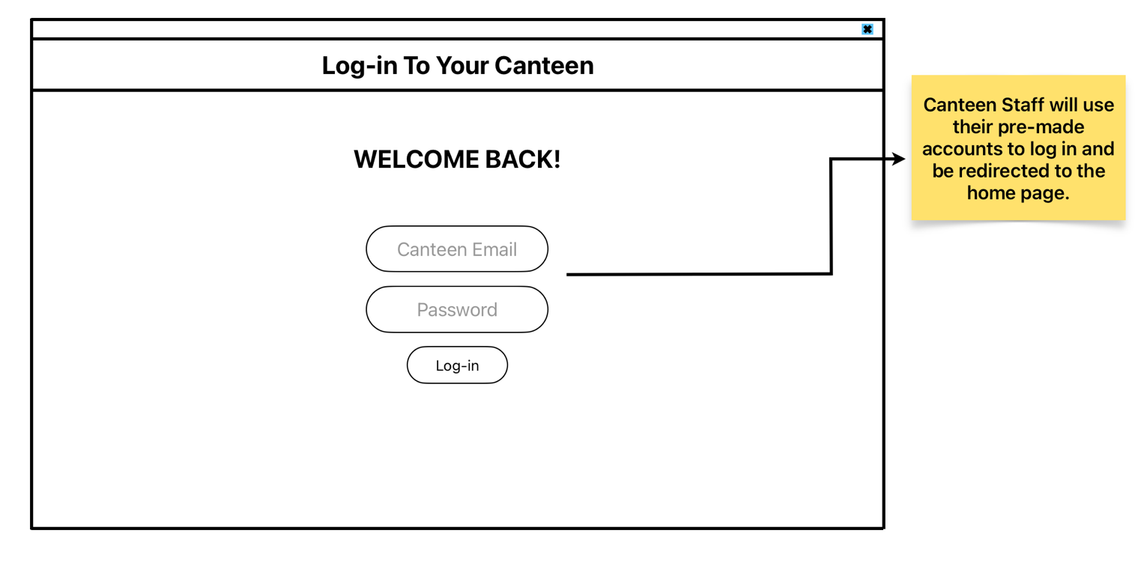
Figure 6: (Teacher’s UI)
Home Page: Homepage has the list of items the user can choose from and add on their cart. Homepage also provides other functionalities for users to have an easier time picking their food such as a dropdown to search by genre or even to search by name.
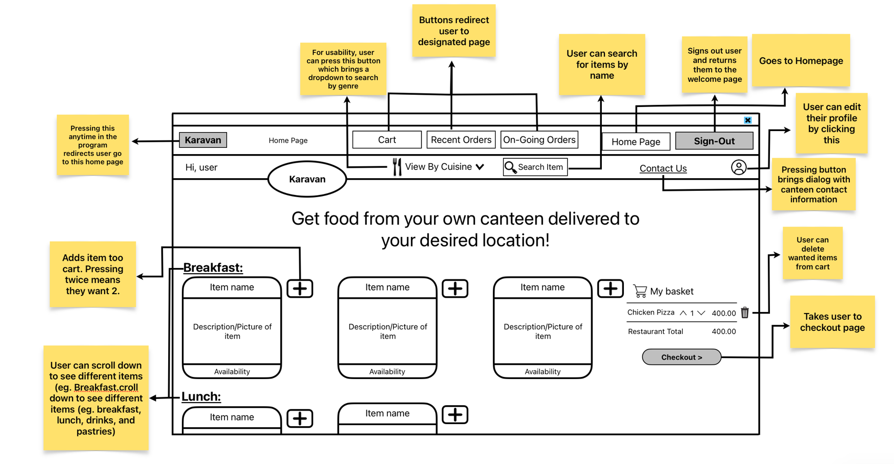

Figure 7: (Teacher’s UI)
Checkout Page: Once user enters all the information needed, they can place their order where they will receive a dialogue showing confirmation their order has been received.
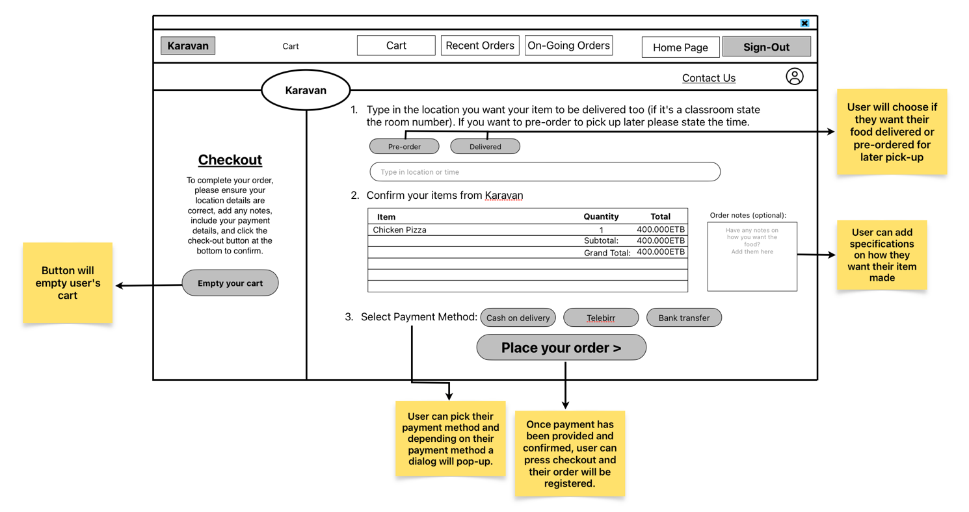
Figure 8: (Teacher’s UI)
Recent Order’s Page: User can check their recent orders and there is quick task buttons to change password and edit profile.
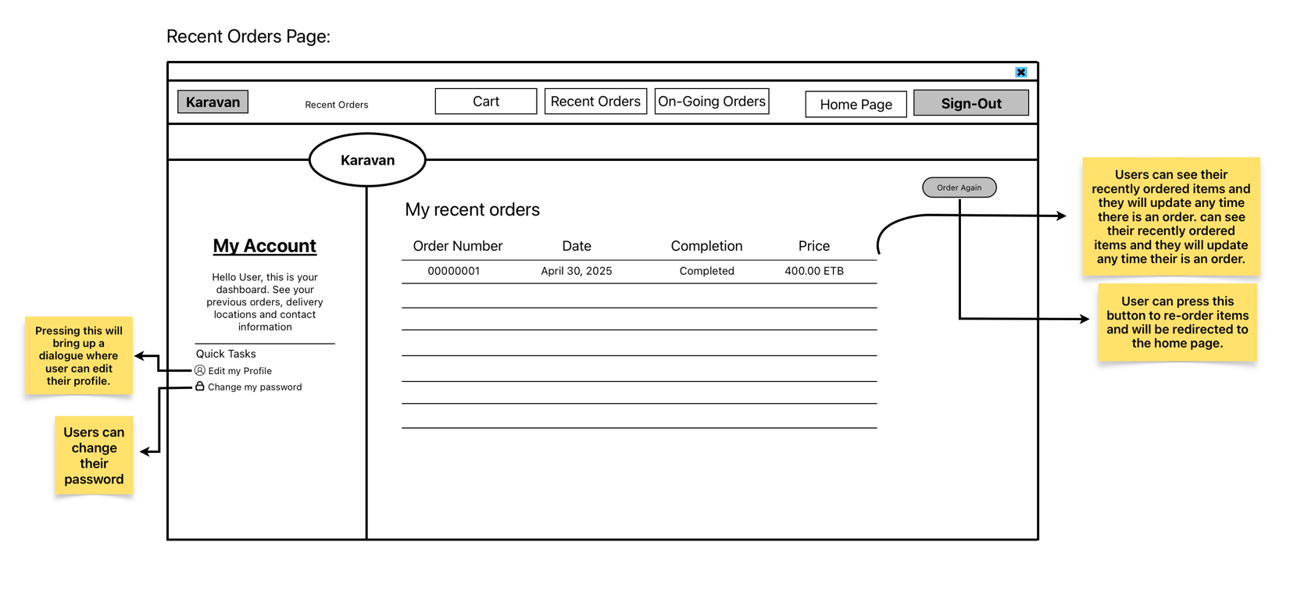

Figure 9: (Teacher’s UI)
Edit my Profile Page: Users can edit their profile name, telephone, and password.
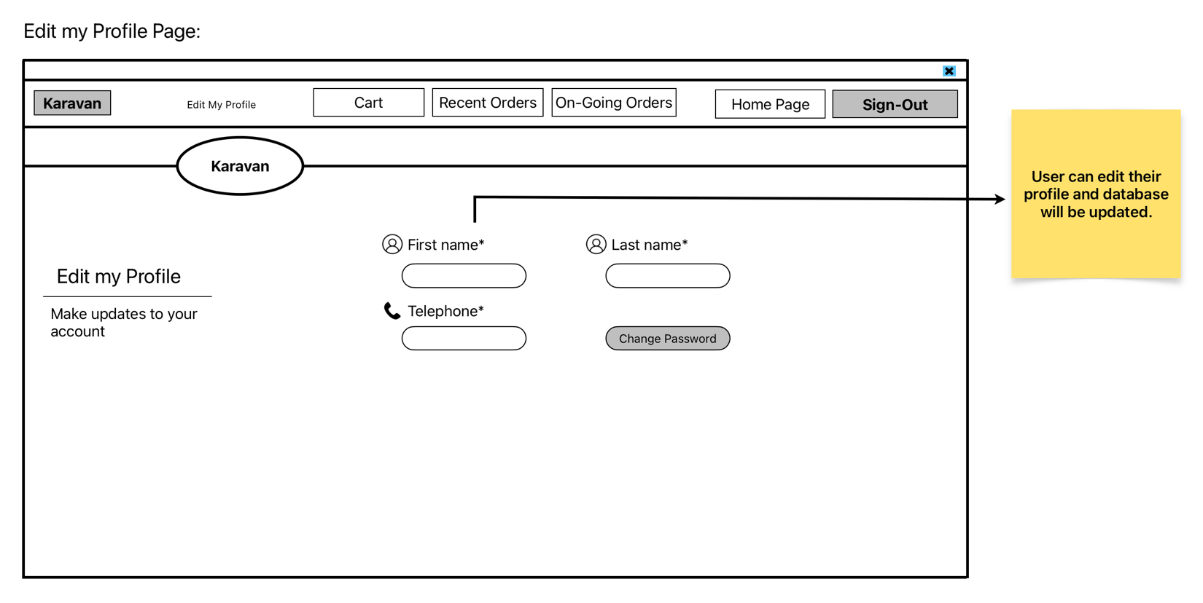
Figure 10: (Canteen UI)
Canteen Staff Home Page: Canteen staff can see how they are doing. They also have a navigation bar to either edit menu items, check incoming orders, check order history or generate reports.
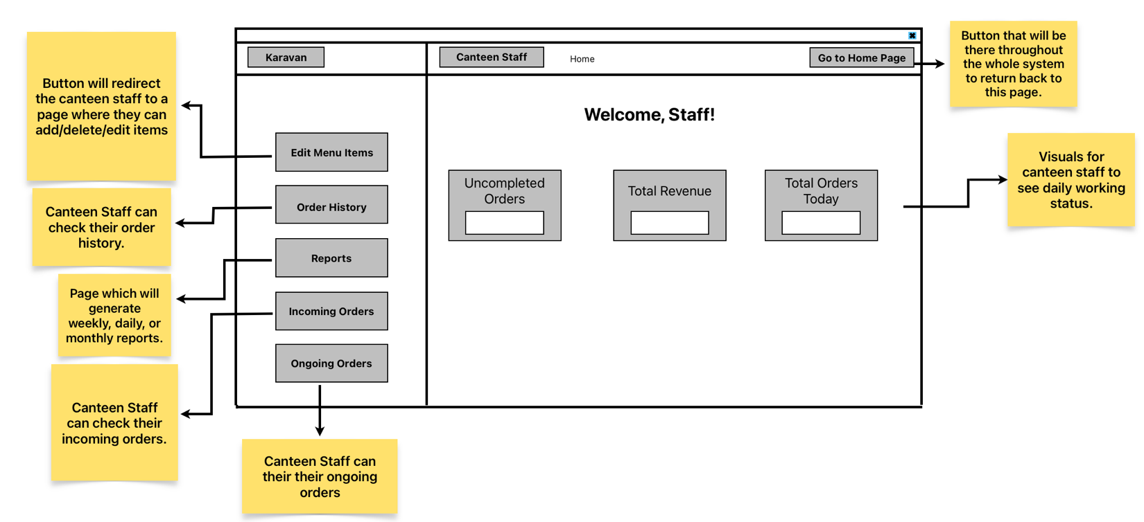

Figure 11: (Canteen UI)
Edit Menu Items Page: Canteen staff can either add, remove or edit menu items and a different dialogue pops up for each of the buttons.
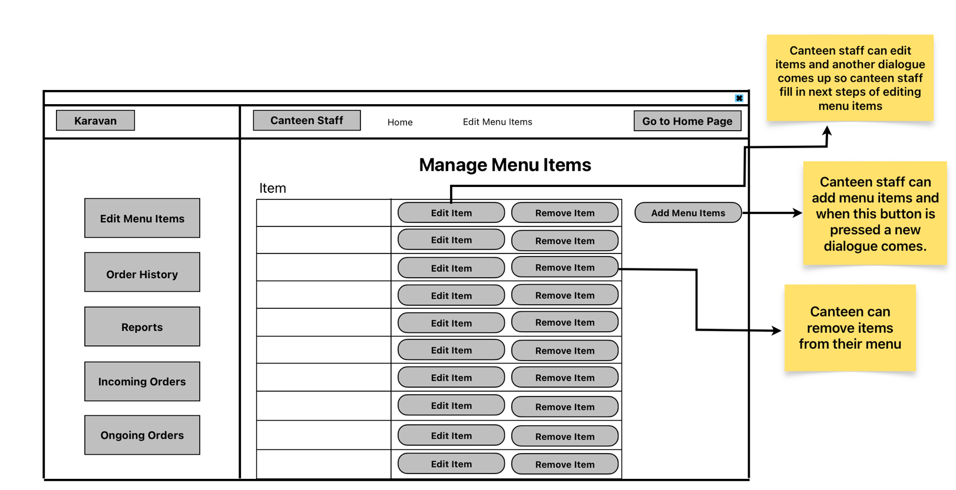
Figure 12: (Canteen UI)
Incoming Orders Page: Canteen Staff can check the orders they are receiving. Once the order is completed, the canteen staff can click the tick button to remove it from the list.
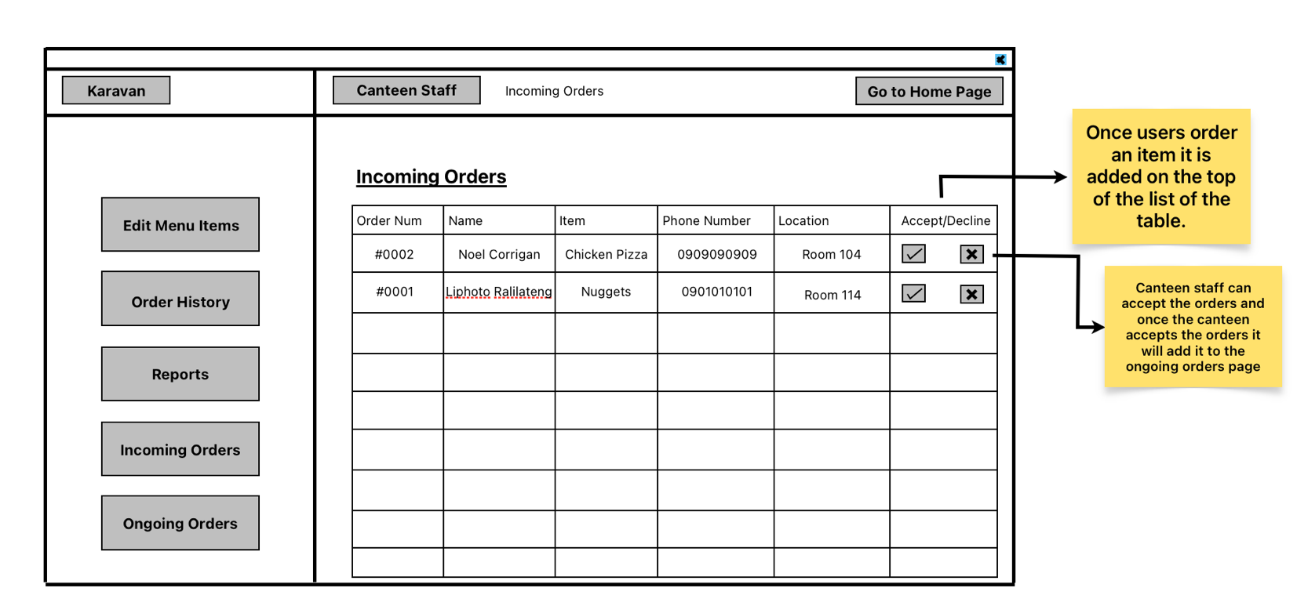

Figure 13: (Canteen UI)
Order History Page: Canteen staff can view their order history by entering a range date or a specific date.
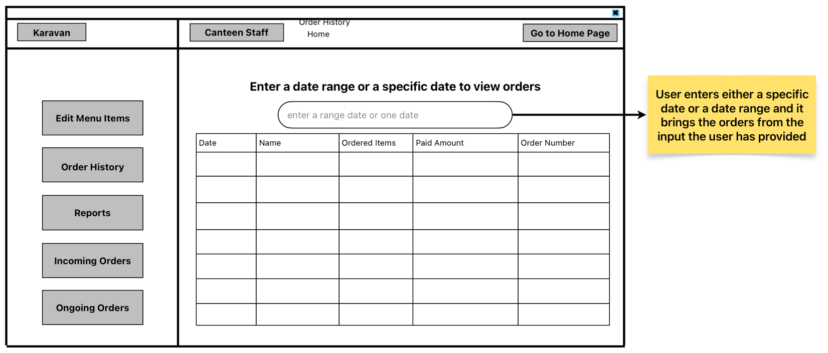
Figure 14: (Canteen UI)
Report Generator Page: Canteen staff can generate daily, weekly or monthly reports to check how they have been doing. Also, they may generate a report for their most ordered item and it will include their most ordered items either daily, weekly or monthly. 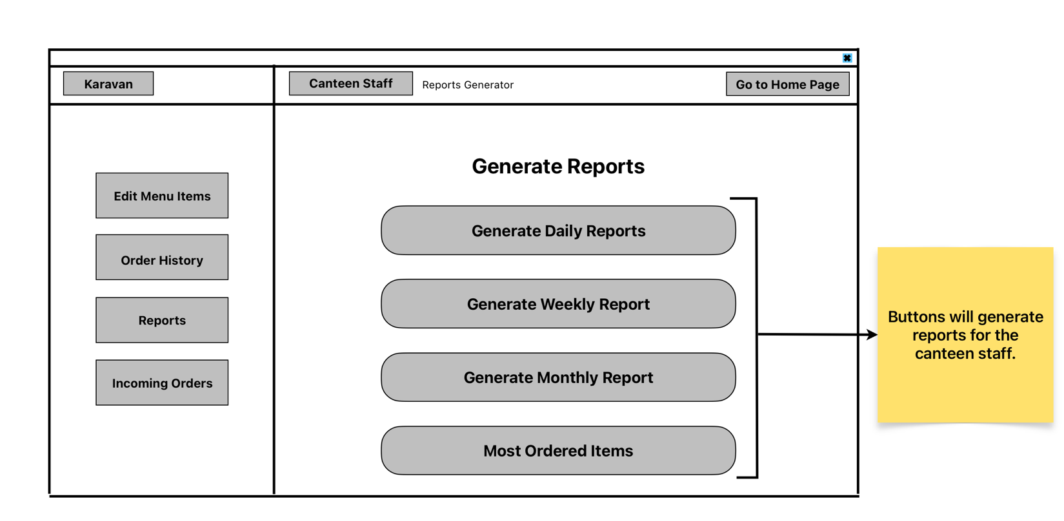

Figure 14: (Canteen UI)
On the ongoing orders page the canteen can check a button to show that it is completed and so it can remove it from the list.
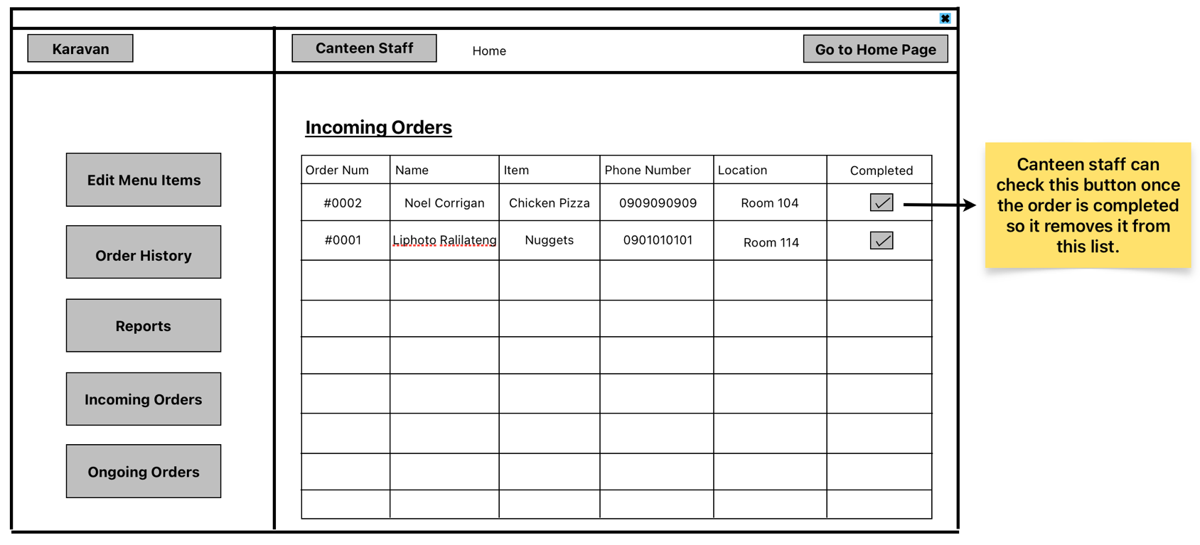

System Flowchart:
Upon receiving the client’s approval on the designs, I made flowcharts on the software Lucidchart to depict the fundamental functions that will help me efficiently incorporate the functions by offering an overview of the flow.
Launch Program:
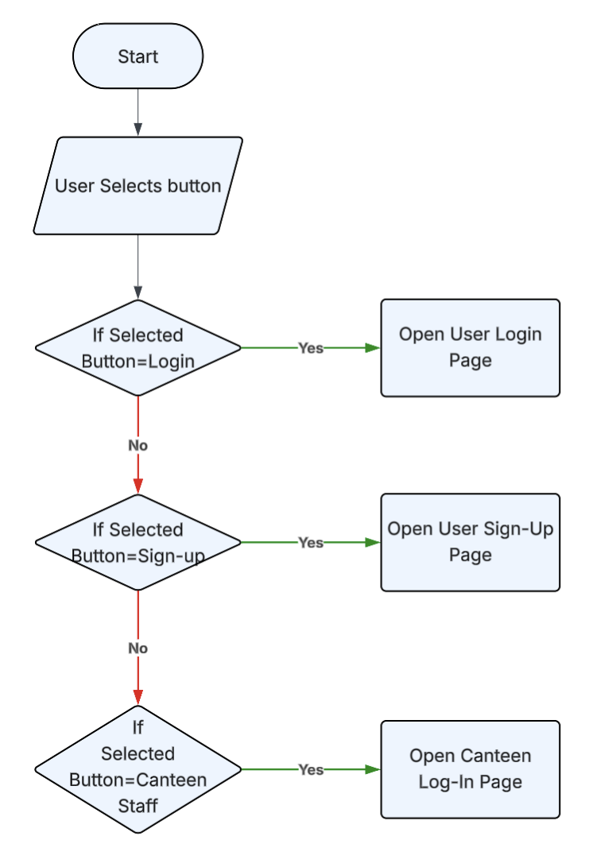

User Panel:

Canteen Panel:

Hierarchical Chart:
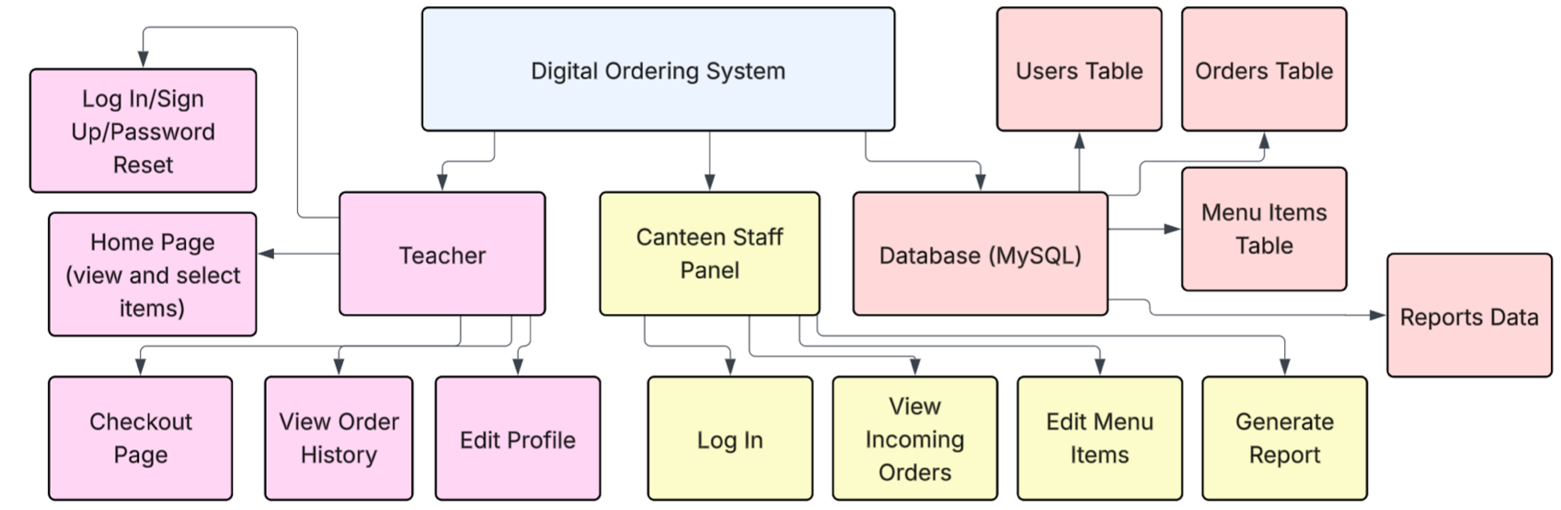

Unified Modeling Language Diagram:

Record of Tasks:
Task Number | Planned Action | Planned Outcome | Time Estimated | Target completion Date | Criterion
1 | Define Project objectives and scope | Clearly articulate the purpose and boundaries of the digital ordering system for the school canteen | 2 hours | April 9, 2025 | A
2 | Conduct Meeting with canteen manager | Gather requirements and challenges associated with the current paper-based system | 2 hours | April 11, 2025 | A
3 | Document requirements and pain points | Compile a full list of functionalities needed and challenges faced by the current system | 1 hour | April 13, 2025 | A
4 | Discuss my proposed solution with my teacher | Validate proposed solution and seek guidance on technical aspects and feasibility | 30 minutes | April 14, 2025 | A
5 | Choose development platform (IntelliJ) | Select appropriate software for system development based on project requirements | 1 hour | April 15, 2025 | A
6 | Develop the success criteria’s | Define specific criteria for evaluating the success of the digital canteen ordering system | 1 hour | April 16, 2025 | A
7 | Feedback on work done until now (Criteria A) | Use feedback to further improve success criterions and writing | 1 hour | April 17, 2025 | A
8 | Sketch design overview | Plan how the system will function in a concise way | 2 hours | April 19, 2025 | B
9 | Design welcome, log-in and sign-up panels. | Plan how users will  authenticate and be  directed to their  respective panels  upon login | 1 day | April 23, 2025 | B
10 | Design home page for user interface | Create a  user-friendly  interface for user so they can pick their menu items easily from the home page. | 1 day | April 24, 2025 | B
11 | Design checkout page for user | Create an easy-to-use checkout page where users can select their payment method and pay for their desired items. | 3 hours | April 25, 2025 | B
12 | Design forgot password functionality and design panel for users to edit their profile | Develop functionality  for users so they can change their password safely and design a user-friendly page so users can easily edit their name or phone number. | 2 hours | April 26, 2025 | B
13 | Implement feature where users can check their recent orders | Design feature where user can check their recent orders based on chronological order or a date they will provide. | 2 hours | April 27, 2025 | B
14 | Design home page for canteen interface. | Create a  user-friendly  interface for canteen staff so they can see daily status of uncompleted orders and more. Homepage also includes a navigation bar to allow easy navigation between different panels. | 2 hours | April 27, 2025 | B
15 | Create panel so canteen staff can add, edit and remove menu items. | Develop a panel where canteen staff can easily edit, add and remove menu items. | 1 hour | April 28, 2025 | B
16 | Design panel where canteen staff can see incoming orders. Panel should also include a functionality where canteen staff state whether the order was completed or not. | Create an easy-to-use interface where canteen staff can view new orders coming. | 2 hours | April 28, 2025 | B
17 | Create panel where canteen staff can check their received order history | Create user-friendly panel where staff can enter a date or date range to check their received orders. | 1 hour | April 28, 2025 | B
18 | Design a panel where canteen staff can generate daily, weekly or monthly reports. | Implement a feature where the canteen can generate a report which will show how the canteen is doing financially, their most ordered items and more. | 2 hours | April 29, 2025 | B

Testing Plan:
Success Criteria No. | Success Criterion | Test Description | Expected Outcome
1 | Role specific login | Log in with valid credentials as both teacher and staff based on user input. | Redirects to correct panel based on user role.
2 | School email check | Try signing up with a non-school email | System blocks sign-up with an error message.
2 | Email verification | Sign up with a valid school email. | System sends verification email before allowing login.
3 | Cancel time limit | Place an order and cancel it within two minutes. | Order is canceled successfully.
3 | Cancel time limit | Try canceling after 2 minutes. | System prevents cancellation and shows message.
4 | Report generation | Place multiple orders with different items. | Report shows correct revenue and most-ordered foods.
5 | Password hashing | Check stored password in database. | Password appears hashed, not in plain text.
6 | Edit profile | Update first name, last name and telephone number. | Profile is updated and displayed correctly.
7 | Change Password | Change password and log in with new one. | Old password fails; new password works.
8 | Ordering system | Select items, add to cart, and place order. | Order is processed and stored accurately.
9 | Optional comments | Add comment with order. | Comment is stored and viewable by staff.
10 | Delivery location | Select delivery location when ordering. | Location is saved and viewable in staff panel.
11 | No duplicates | Try registering same email twice. | System prevents duplicates and shows error.
12 | Order history by date | Search past orders by date or range. | Correct orders are displayed based on date filter.
13 | Received order history | Staff should be able to search past received orders by date or range. | All previously received orders are visible and accurate.
14 | Item management | Staff adds, edits and deletes menu items. | Menu updates are applied and shown correctly.
15 | Incoming orders view | Staff logs in and checks currently received orders. | Incoming orders are displayed in real-time.
16 | Order cutoff time | Try placing order before and after 4:00 PM. | Only orders before 4:00 PM on weekdays are accepted.

